CONSEAACT 2018
Saturday 24 MARCH 2018, The Australian National University

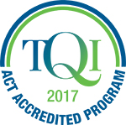 | CONSEAACT 2018 is accredited with TQI for five hours of Professional Learning (Proficient Teacher Level) | 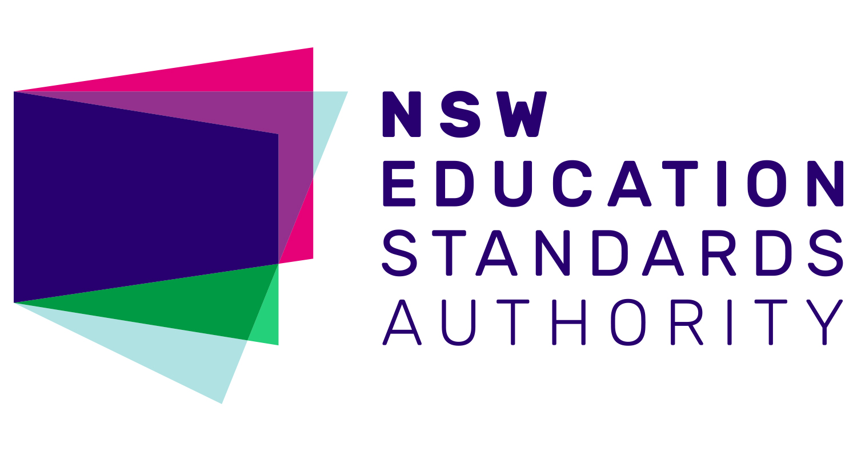 | Completing CONSEAACT will contribute  5 hours of NESA Registered PD addressing 2.1.2 and 3.3.2 from the Australian Professional Standards for Teachers towards maintaining Proficient Teacher Accreditation in NSW.

EC = Early Childhood LP = Lower Primary UP = Upper Primary
JS = Junior Secondary SS = Senior Secondary

8.20 to 8.55 am, Registration
8.55-9.00 am Welcome, Paula Taylor, SEAACT President
9.05 to 9.50 am (45 min), Keynote Speaker
Dr Kai Chan, Australian National University, 2017 ACT Scientist of the Year
Dr Kai Chan from the ANU Research School of Biology was named 2017 ACT Scientist of the Year. Dr Chan's research looks at the effect of drought conditions on plants, and the ways by which some plants can sense drought stress. The Scientist of the Year Award aims to inspire young people to consider a career in science and STEM and Dr Chan is keen to connect with ACT schools and teachers after CONSEAACT.
9.55 to 10.40 am (45 min), Models of STEM Panel Discussion
Models of STEM panel discussion with:
- Lynn Walker (University of Canberra)
- Josephine Andersen (ACT Dept of Education & Training)
- Damian Woods (St Francis Xavier)
- Leah Taylor (Holy Family Primary School).
Members of this discussion panel represent higher education, the ACT Department of Education and Training and two local schools. Panel members will discuss how STEM is being implemented in ACT schools, and audience members are invited to ask panel members about their perspectives on STEM programs for students and schools and what STEM education means for the ACT Education community.
10.40 to 11.10 am (30 min), Morning Tea & Exhibitor Stalls

11.10 am to 12.10 pm (60 min), Session A
Venturing beyond Engage – the 5Es inquiry teaching and learning model (LP, UP)
Nicole McAlester, Australian Academy of Science – PrimaryConnections
Through a hands-on exploration of an Earth & Space sciences concept, participants are given the opportunity to experience an investigative and inquiry approach framed by the 5Es teaching and learning model. This workshop is designed to deepen knowledge and understanding of the 5Es model so that it can be applied and transferred to classroom practice with confidence.
Hands on science - The ANU Physics Box (UP, JS, SS)
Nick Robins & Andrew Papworth, Australian National University
Andrew and Nick will present the free physics box initiative and go through a number of experiments that you can do with your students from gear in the box and beyond.
Four experiments for the year 10 Earth and Space Sciences Unit (JS, SS)
Colin Price, Daramalan College
Participants will carry out a simple experiment that models granulation on the Sun, and construct and use a biscuit box CD spectroscope that makes Fraunhofer lines visible. Then two effective ‘cosmic distance ladder’ experiments on the parallax method and the inverse distance squared law will be demonstrated.
12.15 to 1.15 pm (60 min), Session B
Science inquiry for early childhood (EC, LP)
Belinda Anyos, Questacon
Questacon’s Science Time program has been running for more than a decade and is built on a foundation that encourages young children to understand their environment through play and exploratory questions. The Science Time team models how adults (who are accompanying young children to the program) to ask ‘little scientists’ inquiry-based questions to help young children to express themselves and to develop their science inquiry skills. This session will share ideas and techniques for early childhood teachers wanting to extend their young students through science inquiry.
Water Bug Survey – Hands On Ecology (UP, JS, SS)
Phil Dunne, ACT Department of Education and Training
Quantitative measures of aquatic invertebrates are made by citizen science groups like Waterwatch and these methods can be taught to students. Presence or absence of certain species can be indicative of water quality. Students learn about taxonomy, population measures and practice interpreting data. Microscope use is an extension activity.
Astronomy presentation (All year levels)
Dr Brad Tucker ANU Mount Stromlo Observatory
In the past few decades, rapid progress in ground-based and spaced-based technology has led to rapid progress. In the next few decades, this will change even more as we become an inter-planetary species. Brad will cover some of these new and current projects, how we are now turning science fiction into reality, and how we can bring these possibilities into the classroom.
Geology fieldwork at school – using rock knowledge for inquiry (JS, SS)
Shona Blewett, Geoscience
Geological science is often advanced through fieldwork but most Year 8 students don’t experience this during the rocks unit. Participants will take part in a simulated rock mapping activity that can be set up in any school grounds; they will learn how to develop their map and a geological history and discuss how to use the activity effectively with their own students.
1.15 to 1.45 pm, (30 min), Lunch & Exhibitor Stalls
1.50 to 2.35 pm (45 min), Session C
ANU MeriSTEM Flipped Classroom (JS, SS)
Ethan Barden and Joe Hope, Australian National University
Flipped education brings a slew of well documented benefits for learning outcomes, but producing the necessary materials is time intensive. Joe and Ethan will talk about MeriSTEM, a project that makes flipping materials and distributes them freely. They will share tips and tricks for teachers thinking about flipping their classes.
Storytelling through STEM (EC, LP)
Cindy Chambers, SEAACT PL Officer
Discover how stories about family, the environment or different cultures can be told using interactive displays. This hands-on session allows you to flex your imagination, creativity and experimentation skills, using unpowered technology that can be re-used each year.
ASTA ScienceASSIST (UP, JS, SS) Delese Brewster, Australian Science Teachers Association
The Australian Science Teachers Association’s online portal called ScienceASSIST is a highly valuable resource for classroom teachers and laboratory technicians. The portal provides free access to scaffolded lesson plans called Connected Learning Experiences (CLEs) as well as a forum which allows teachers and lab assistants to ask questions and access responses from experience practitioners. Jodie Lawson-Santos will uncover features of ScienceASSIST to use as soon as you return to your classroom and support your practice in the future.
2.40 to 3.30 pm (50 min), Closing Session
Questacon Science Show and drinks (All year levels)
Excited Particles, Questacon
Grab a drink and a quick opportunity to network with colleagues before sitting down to enjoy CONSEACT’s closing science show by Questacon’s Excited Particles presenters.

CONSEAACT 2018
Saturday 24 MARCH 2018, The Australian National University

Registration Form and Tax Invoice

PLEASE PRINT CLEARLY AND USE BLOCK LETTERS
Name: Click here to enter text.
School: Click here to enter text.
Mobile Number: Click here to enter text.
Email: Click here to enter text. | TQI #: Click here to enter text.
Dietary Requirements: Click here to enter text.
Photos taken on the day may be used by SEAACT for our publications and website. If you DO NOT give SEAACT consent to use your images for publicity purposes, please tick this box |  | ☐ | Check if you DO NOT grant consent

 | SEAACT Members and  STANSW Members |  | Non–members
Full Day Conference  (morning tea and lunch provided)  Preservice and Early Career teachers | ☐  ☐ | $75.00 Incl. GST  $35.00 Incl. GST | ☐  ☐ | $100.00 Incl. GST  $45.00 Incl. GST

Method of payment:

☐ Cheque (made payable to SEAACT: ABN 78 948 251 953)

☐ Mastercard ☐ Visa ☐ Bankcard

Card number Click here to enter text.

Cardholder name Click here to enter text.

Expiry date Click here to enter text. Amount $ Click here to enter text.

Cardholder signature Click here to enter text.

☐Direct debit Bank Details: Commonwealth Bank of Australia
BSB: 062 908
Account number: 0090 7189
Please quote CONSEAACT (your surname)

Please RSVP before 20 March 2018 at seaact@y7mail.com
and select your CONSEAACT sessions at https://www.surveymonkey.com/r/CONSEAACT2018Sessions

