
CONSEAACT 2018
Saturday 24 MARCH 2018, ANU Robertson building (No. 46)

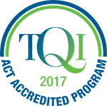 | CONSEAACT 2018 is accredited with TQI for five hours of Professional Learning (Proficient Teacher Level) | 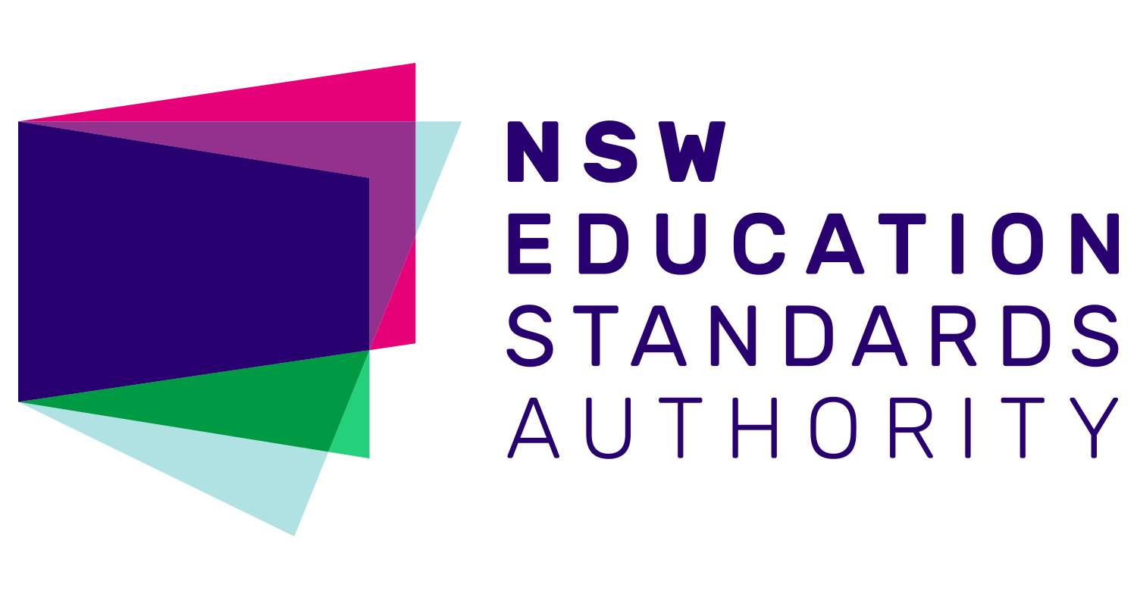 | Completing CONSEAACT will contribute  5 hours of NESA Registered PD addressing 2.1.2 and 3.3.2 from the Australian Professional Standards for Teachers towards maintaining Proficient Teacher Accreditation in NSW.
EC = Early Childhood LP = Lower Primary UP = Upper Primary JS = Junior Secondary SS = Senior Secondary

8.20 to 8.55 am, Registration
8.55-9.00 am Welcome, Paula Taylor, SEAACT President
9.05 to 9.50 am (45 min), Keynote Speaker Eucalyptus Room
Dr Kai Chan, ANU, 2017 ACT Scientist of the Year
Dr Kai Chan from the ANU Research School of Biology was named 2017 ACT Scientist of the Year. Dr Chan's research looks at the effect of drought conditions on plants, and the ways by which some plants can sense drought stress. Dr Chan is keen to connect with ACT schools and students to inspire young people to consider a career in science and STEM.
9.55 to 10.40 am (45 min), Models of STEM Panel Discussion Eucalyptus Room
Panel members Lynn Walker (University of Canberra); Josephine Andersen (ACT Dept of Education & Training); Damian Woods (St Francis Xavier) and Leah Taylor (Holy Family Primary School).will discuss how STEM is being implemented in ACT schools. Audience members are invited to ask panel members about their perspectives on STEM programs for students and schools and what STEM education means for the ACT Education community.
10.40 to 11.10 am (30 min), Morning Tea & Exhibitor Stalls
Session A: 11.10 am to 12.10 pm (60 min)
Venturing beyond Engage – the 5Es inquiry teaching and learning model (EC, LP, UP, JS) Undergrad Lab (Level 1)
Nicole McAlester, Australian Academy of Science – PrimaryConnections
Through a hands-on exploration of an Earth & Space sciences concept, participants are given the opportunity to experience an investigative and inquiry approach framed by the 5Es teaching and learning model. This workshop is designed to deepen knowledge and understanding of the 5Es model so that it can be applied and transferred to classroom practice with confidence.
Hands on science - The ANU Physics Box (UP, JS, SS) Anderson Room
Nick Robins & Andrew Papworth, Australian National University
Andrew and Nick will present the free physics box initiative and go through a number of experiments that you can do with your students from gear in the box and beyond.
Four experiments for the Year 10 Earth and space sciences unit The Universe and the Big Bang Theory (JS, SS) Eucalyptus Room
Colin Price, Daramalan College
Participants will carry out a simple experiment that models granulation on the Sun, and construct and use a biscuit box CD spectroscope that makes Fraunhofer lines visible. Then two effective ‘cosmic distance ladder’ experiments on the parallax method and the inverse distance squared law will be demonstrated.

Session B: 12.15 to 1.15 pm (60 min)
Science inquiry for early childhood (EC, LP) Anderson Room
Belinda Anyos, Questacon
Questacon’s Science Time program models how adults (who are accompanying young children to the program) to ask ‘little scientists’ inquiry-based questions to help young children to express themselves and to develop their science inquiry skills. This session will share ideas and techniques for early childhood teachers wanting to extend their young students through science inquiry.
Water Bug Survey – Hands On Ecology (UP, JS, SS) Undergrad Lab (Level 1)
Phil Dunne, ACT Dept of Education and Training
Quantitative measures of aquatic invertebrates are made by citizen science groups like Waterwatch and these methods can be taught to students. Presence or absence of certain species can be indicative of water quality. Students learn about taxonomy, population measures and practice interpreting data. Microscope use is an extension activity.
Astronomy presentation (All year levels) Eucalyptus Room
Dr Brad Tucker ANU Mount Stromlo Observatory
In the past few decades, rapid progress in ground-based and spaced-based technology has led to rapid progress. In the next few decades, this will change even more as we become an inter-planetary species. Brad will cover some of these new and current projects, how we are now turning science fiction into reality, and how we can bring these possibilities into the classroom.
Geology fieldwork at school – using rock knowledge for inquiry (JS, SS) Slatyer Room
Shona Blewett, Geoscience Australia
Geological science is often advanced through fieldwork but most Year 8 students don’t experience this during the rocks unit. Participants will take part in a simulated rock mapping activity that can be set up in any school grounds; they will learn how to develop their map and a geological history and discuss how to use the activity effectively with their own students.
1.15 to 1.45 pm, (30 min), Lunch & Exhibitor Stalls
Session C: 1.50 to 2.35 pm (45 min)
ANU MeriSTEM Flipped Classroom (JS, SS) Undergrad Lab (Level 1)
Ethan Barden and Joe Hope, ANU
Flipped education brings a slew of well documented benefits for learning outcomes, but producing the necessary materials is time intensive. Joe and Ethan will talk about MeriSTEM, a project that makes flipping materials and distributes them freely. They will share tips and tricks for teachers thinking about flipping their classes.
Early Learning STEM Australia (ELSA) (EC, LP) Rainforest Room
Rob Fitzgerald, University of Canberra
Using digital apps and play-based activities, the program is designed to help early childhood educators encourage their children to explore science, technology, engineering and mathematics (STEM). ELSA will be piloted in 2018, and CONSEAACT attendees will gain a preview of how ELSA could assist teachers in sharing STEM with their students.
Food and Fibre, The Original STEM (LP, UP) Slatyer Room
Ben Stockwin, PIEFA (Primary Industries Education Foundation Australia)
Did you know that thanks to science we can produce more food using less water, less chemicals with more nutritional density than ever before? Primezone is the one stop web portal that provides teachers with hundreds of FREE resources to help you explore this through your science lessons. Chance to win a free copy of Primezone/PrimaryConnections’ resource Rising Salt
ASTA ScienceASSIST (UP, JS, SS) Anderson Room
Delese Brewster, ASTA
ASTA’s online portal called ScienceASSIST is a highly valuable resource for classroom teachers and laboratory technicians. The portal provides free access to scaffolded lesson plans called Connected Learning Experiences (CLEs) as well as a forum which allows teachers and lab assistants to ask questions and access responses from experience practitioners.
Closing Session D: 2.40 to 3.30 pm (45 min), Eucalyptus Room
Grab a drink and a quick opportunity to network with colleagues before sitting down to enjoy CONSEAACT’s closing science show by Questacon’s Excited Particles presenters


Conference of the Science Educators Association of the ACT
CONSEAACT 2018
Science Educators’ Association
of the Australian Capital Territory

Saturday 24 MARCH 2018
ANU Robertson building (#46)

Registration Form and Tax Invoice

PLEASE PRINT CLEARLY AND USE BLOCK LETTERS
Name: Click here to enter text.
School: Click here to enter text.
Mobile Number: Click here to enter text.
Email: Click here to enter text. | TQI #: Click here to enter text.
Dietary Requirements: Click here to enter text.
Photos taken on the day may be used by SEAACT for our publications and website. If you DO NOT give SEAACT consent to use your images for publicity purposes, please tick this box |  | ☐ | Check if you DO NOT grant consent

 | SEAACT Members and  STANSW Members |  | Non–members
Full Day Conference  (morning tea and lunch provided)  Preservice and Early Career teachers | ☐  ☐ | $75.00 Incl. GST  $35.00 Incl. GST | ☐  ☐ | $100.00 Incl. GST  $45.00 Incl. GST

Method of payment:

☐ Cheque (made payable to SEAACT: ABN 78 948 251 953)

☐ Mastercard ☐ Visa ☐ Bankcard

Card number Click here to enter text.

Cardholder name Click here to enter text.

Expiry date Click here to enter text. Amount $ Click here to enter text.

Cardholder signature Click here to enter text.

☐Direct debit Bank Details: Commonwealth Bank of Australia
BSB: 062 908
Account number: 0090 7189
Please quote CONSEAACT (your surname)

Please RSVP before 17 March 2018 at seaact@y7mail.com
Time | Session name | Room | Early childhood | Lower primary | Upper primary | Junior Secondary | Senior Secondary | Please select your sessions below
8.55-to 9.00 am | Welcome by SEAACT President Paula Taylor | Eucalyptus Room | √ | √ | √ | √ | √ | ☐
9.05 to 9.50 am | Keynote Speaker, Dr Kai Chan | Eucalyptus Room | √ | √ | √ | √ | √ | ☐
9.55 to 10.40 am | Models of STEM Panel Discussion | Eucalyptus Room | √ | √ | √ | √ | √ | ☐
Morning tea & Exhibitors, 10.40 to 11.10 am
Session A: 11.10 am to 12.10 pm
Venturing Beyond Engage—the 5Es inquiry teaching and learning model (Primary Connections) |  | Undergrad Lab, Level 1 | √ | √ | √ | √ |  | ☐
Astronomy Presentation by Brad Tucker |  | Eucalyptus Room |  | √ | √ | √ | √ | ☐
Hands-On Science – The ANU Physics Box |  | Anderson Room |  |  | √ | √ | √ | ☐
Session B: 12.15 to 1.15 pm
Science Inquiry for Early Childhood  (Questacon) |  | Anderson Room | √ | √ |  |  |  | ☐
Geology fieldwork at school, using rock knowledge for inquiry (Geoscience Australia) |  | Slatyer  Room |  |  | √ | √ |  | ☐
Water Bug Survey – Hands On Ecology  (Phil Dunne) |  | Undergrad Lab, Level 1 |  |  | √ | √ | √ | ☐
Four experiments Yr 10 Earth & space sciences  (Colin Price) |  | Eucalyptus Room |  |  | √ | √ |  | ☐
Lunch & Exhibitors: 1.15 to 1.45 pm
Session C: 1.50 to 2.35 pm
MeriSTEM Flipped Classroom  (ANU) |  | Eucalyptus Room |  |  |  | √ | √ | ☐
ELSA Early Learning STEM Australia  (University of Canberra) |  | Rainforest Room | √ |  |  |  |  | ☐
Food and Fibre, The Original STEM  (PIEFA) |  | Slatyer  Room |  | √ | √ |  |  | ☐
ASTA ScienceASSIST |  | Anderson Room |  |  | √ | √ | √ | ☐
Closing Session D: 2.40 to 3.30 pm
Science demo show and drinks |  | Eucalyptus Room | √ | √ | √ | √ | √ | ☐

