CONSEAACT 2018
Saturday 24 MARCH 2018, The Australian National University

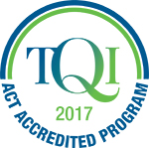 | CONSEAACT 2018 is accredited with TQI for five hours of Professional Learning (Proficient Teacher Level) | 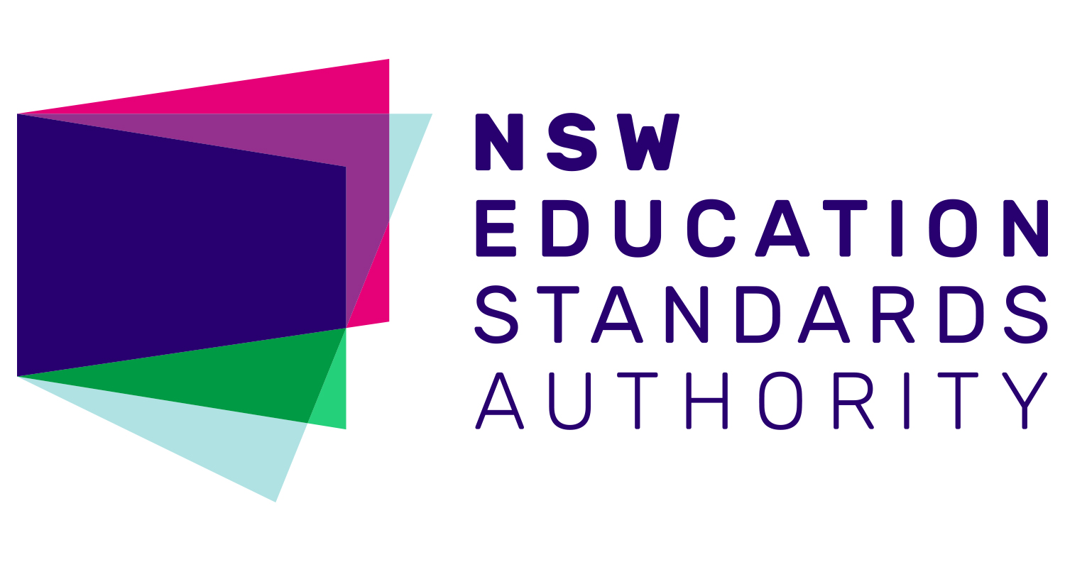 | Completing CONSEAACT will contribute  5 hours of NESA Registered PD addressing 2.1.2 and 3.3.2 from the Australian Professional Standards for Teachers towards maintaining Proficient Teacher Accreditation in NSW.

EC = Early Childhood LP = Lower Primary UP = Upper Primary
JS = Junior Secondary SS = Senior Secondary

8.20 to 8.55 am, Registration
8.55-9.00 am Welcome, Paula Taylor, SEAACT President
9.05 to 9.50 am (45 min), Keynote Speaker
Dr Kai Chan, ANU, 2017 ACT Scientist of the Year
Dr Kai Chan from the ANU Research School of Biology was named 2017 ACT Scientist of the Year. Dr Chan's research looks at the effect of drought conditions on plants, and the ways by which some plants can sense drought stress. The Scientist of the Year Award aims to inspire young people to consider a career in science and STEM and Dr Chan is keen to connect with ACT schools and teachers after CONSEAACT.
9.55 to 10.40 am (45 min), Models of STEM Panel Discussion
Models of STEM panel discussion with:
- Lynn Walker (University of Canberra)
- Josephine Andersen (ACT Dept of Education & Training)
- Damian Woods (St Francis Xavier)
- Leah Taylor (Holy Family Primary School).
Members of this discussion panel represent higher education, the ACT Department of Education and Training and two local schools. Panel members will discuss how STEM is being implemented in ACT schools, and audience members are invited to ask panel members about their perspectives on STEM programs for students and schools and what STEM education means for the ACT Education community.
10.40 to 11.10 am (30 min), Morning Tea & Exhibitor Stalls

11.10 am to 12.10 pm (60 min), Session A
Venturing beyond Engage – the 5Es inquiry teaching and learning model (LP, UP)
Nicole McAlester, Australian Academy of Science – PrimaryConnection
Through a hands-on exploration of an Earth & Space sciences concept, participants are given the opportunity to experience an investigative and inquiry approach framed by the 5Es teaching and learning model. This workshop is designed to deepen knowledge and understanding of the 5Es model so that it can be applied and transferred to classroom practice with confidence.
Water Bug Survey – Hands On Ecology (UP, JS, SS)
Phil Dunne, ACT Dept of Education and Training
Quantitative measures of aquatic invertebrates are made by citizen science groups like Waterwatch and these methods can be taught to students. Presence or absence of certain species can be indicative of water quality. Students learn about taxonomy, population measures and practice interpreting data. Microscope use is an extension activity.
Astronomy presentation (All year levels)
Dr Brad Tucker ANU Mount Stromlo Observatory
In the past few decades, rapid progress in ground-based and spaced-based technology has led to rapid progress. In the next few decades, this will change even more as we become an inter-planetary species. Brad will cover some of these new and current projects, how we are now turning science fiction into reality, and how we can bring these possibilities into the classroom.
Hands on science - The ANU Physics Box (UP, JS, SS)
Nick Robins & Andrew Papworth, Australian National University
Andrew and Nick will present the free physics box initiative and go through a number of experiments that you can do with your students from gear in the box and beyond.
12.15 to 1.15 pm (60 min), Session B
Science inquiry for early childhood (EC, LP)
Questacon presenters TBA
Questacon’s Science Time program has been running for more than a decade and is built on a foundation that encourages young children to understand their environment through play and exploratory questions. The Science Time team models how adults (who are accompanying young children to the program) to ask ‘little scientists’ inquiry-based questions to help young children to express themselves and to develop their science inquiry skills. This session will share ideas and techniques for early childhood teachers wanting to extend their young students through science inquiry.
ASTA ScienceASSIST (UP, JS, SS) Jodie Lawson-Santos, Garran Primary School
The Australian Science Teachers Association’s online portal called ScienceASSIST is a highly valuable resource for classroom teachers and laboratory technicians. The portal provides free access to scaffolded lesson plans called Connected Learning Experiences (CLEs) as well as a forum which allows teachers and lab assistants to ask questions and access responses from experience practitioners. Jodie Lawson-Santos will uncover features of ScienceASSIST to use as soon as you return to your classroom and support your practice in the future.
Geoscience (UP, JS)
Geoscience presenter TBA
Participate in this hands-on workshop and discover how to run a rock mapping fieldwork activity in your school grounds. Links to the Australian Curriculum Science will be provided.

1.15 to 1.45 pm, (30 min), Lunch & Exhibitor Stalls
1.50 to 2.35 pm (45 min), Session C
ANU MeriSTEM Flipped Classroom (JS, SS)
Ethan Barden and Joe Hope, ANU
Flipped education brings a slew of well documented benefits for learning outcomes, but producing the necessary materials is time intensive. Joe and Ethan will talk about MeriSTEM, a project that makes flipping materials and distributes them freely. They will share tips and tricks for teachers thinking about flipping their classes.
Early Learning STEM Australia (ELSA) (EC, LP)
Rob Fitzgerald, University of Canberra
ELSA is a play-based digital learning program for children in preschool. Using digital apps and play-based activities, the program is designed to help early childhood educators encourage their children to explore science, technology, engineering and mathematics (STEM). ELSA will be piloted in 2018, and CONSEAACT attendees will gain a preview of how ELSA could assist teachers in sharing STEM with their students.
Food and Fibre, The Original STEM (LP, UP)
Ben Stockwin, PIEFA (Primary Industries Education Foundation Australia)
Did you know that thanks to science we can produce more food using less water, less chemicals with more nutritional density than ever before? Primezone is the one stop web portal that provides teachers with hundreds of FREE resources to help you explore this through your science lessons. One lucky participant will win a free copy of the new primary Connections resource ‘Rising Salt’ produced with the support of Primezone.
2.40 to 3.30 pm (50 min), Plenary
Science Show Offs (All year levels)
Dr Graham Walker, ANU National Centre for the Public Awareness of Science
Graham has taken science to over a million people in Australia and overseas using exciting live science shows, TV, hands-on activities, and workshops for teachers and students. Apart from performing science shows, Graham does research on what effects they have on audiences. He’s particularly interested in how science shows can inspire, motivate and provoke emotions.

Time | Session name | Room | Early childhood | Lower primary | Upper primary | Junior Secondary | Senior Secondary
8.55 to 9.00 am | Welcome by SEAACT President Paula Taylor | Theatre | √ | √ | √ | √ | √
9.05 to 9.50 am | Keynote Speaker, Dr Kai Chan | Theatre | √ | √ | √ | √ | √
9.55 to 10.40 am | Models of STEM Panel Discussion | Theatre | √ | √ | √ | √ | √
10.40 to 11.10 am | Morning tea & Exhibitors
Session A  11.10 am to  12.10 pm | Venturing Beyond Engage—the 5Es inquiry teaching and learning model (Primary Connections) | TBA |  | √ | √
 | Water Bug Survey – Hands On Ecology | TBA |  |  | √ | √ | √
 | Astronomy Presentation | TBA |  | √ | √ | √ | √
 | Hands-On Science – The ANU Physics Box | TBA |  |  | √ | √ | √
Session B  12.15 to 1.15 pm | Science Inquiry for Early Childhood (Questacon) | TBA | √ | √
 | ASTA ScienceASSIST | TBA |  |  | √ | √ | √
 | Geoscience Australia Rock Mapping | TBA |  |  | √ | √
1.15 to 1.45 pm | Lunch & Exhibitors
Session C  1.50 to 2.35 pm | MeriSTEM Flipped Classroom (ANU) | TBA |  |  |  | √ | √
 | ELSA Early Learning STEM Australia (University of Canberra) | TBA | √
 | Food and Fibre, The Original STEM (PIEFA) | TBA |  | √ | √
Session D  2.40 to 3.30 pm | Plenary: Dr Graham Walker Science Show Offs | Theatre | √ | √ | √ | √ | √

